Blackboard Pattern
# Source: AI Source: Provided by: [Data Path: Persons Table -> ID Column: 1, Name_En Column: Motasem Essam] -> From: [ChatGPT] on [1/23/2026]
The Blackboard Pattern is an architectural pattern used for complex problem-solving systems where multiple specialized components work together to solve a problem incrementally.
👉 Think of it as a shared workspace (blackboard) where different experts contribute pieces of knowledge until a solution emerges.

🔑 Key Idea
# Source: AI Source: Provided by: [Data Path: Persons Table -> ID Column: 1, Name_En Column: Motasem Essam] -> From: [ChatGPT] on [1/23/2026]
- A central knowledge base (blackboard) holds the current state of the solution
- Specialist modules (knowledge sources) contribute their expertise when relevant
- Control component decides which module acts next

🧱 Structure
# Source: AI Source: Provided by: [Data Path: Persons Table -> ID Column: 1, Name_En Column: Motasem Essam] -> From: [ChatGPT] on [1/23/2026]
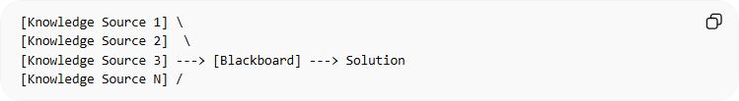
[Knowledge Source 1] \
[Knowledge Source 2] \
[Knowledge Source 3] ---> [Blackboard] ---> Solution
[Knowledge Source N] /
- Blackboard → Shared memory with partial solutions
- Knowledge Sources → Independent modules solving subproblems
- Control → Manages flow and execution

🧩 Example – Speech Recognition System
# Source: AI Source: Provided by: [Data Path: Persons Table -> ID Column: 1, Name_En Column: Motasem Essam] -> From: [ChatGPT] on [1/23/2026]
- Blackboard → Current interpretation of spoken words
- Knowledge Sources → Modules for:
  - Acoustic analysis
  - Phoneme recognition
  - Grammar rules
  - Context analysis
- Control Component → Chooses which module contributes next
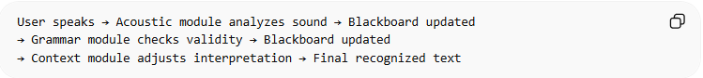
User speaks → Acoustic module analyzes sound → Blackboard updated
→ Grammar module checks validity → Blackboard updated
→ Context module adjusts interpretation → Final recognized text

❌ Bad Example (No Blackboard Coordination)
# Source: AI Source: Provided by: [Data Path: Persons Table -> ID Column: 1, Name_En Column: Motasem Essam] -> From: [ChatGPT] on [1/23/2026]
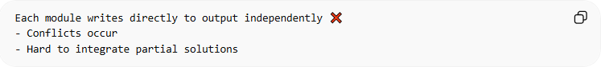
Each module writes directly to output independently ❌
- Conflicts occur
- Hard to integrate partial solutions

✅ Good Example (With Blackboard)
# Source: AI Source: Provided by: [Data Path: Persons Table -> ID Column: 1, Name_En Column: Motasem Essam] -> From: [ChatGPT] on [1/23/2026]
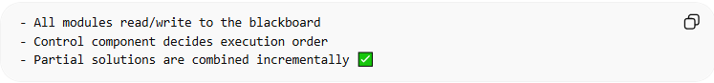
- All modules read/write to the blackboard
- Control component decides execution order
- Partial solutions are combined incrementally ✅

🔄 Use Cases
# Source: AI Source: Provided by: [Data Path: Persons Table -> ID Column: 1, Name_En Column: Motasem Essam] -> From: [ChatGPT] on [1/23/2026]
- Speech recognition
- Image understanding and vision systems
- AI expert systems
- Complex scientific simulations

⚠️ Common Mistakes
# Source: AI Source: Provided by: [Data Path: Persons Table -> ID Column: 1, Name_En Column: Motasem Essam] -> From: [ChatGPT] on [1/23/2026]
- No clear control mechanism ❌
- Knowledge sources overwrite each other ❌
- Blackboard becomes a bottleneck ❌

💡 Key Idea
# Source: AI Source: Provided by: [Data Path: Persons Table -> ID Column: 1, Name_En Column: Motasem Essam] -> From: [ChatGPT] on [1/23/2026]
The Blackboard Pattern is ideal for problems where multiple independent specialists must cooperate, and no single module can solve the problem alone.

🧾 Summary
# Source: AI Source: Provided by: [Data Path: Persons Table -> ID Column: 1, Name_En Column: Motasem Essam] -> From: [ChatGPT] on [1/23/2026]
- Blackboard → shared solution state
- Knowledge Sources → independent problem-solving modules
- Control → orchestrates contributions
- Best for complex AI and expert systems

